**PIZZA SALES SQL QUERIES**

**A. KPI’s**

**1. Orders(عدد الطلبات لكل حالة):**

select Status,Count(Distinct OrderID) AS Orders

from SQLToturial.dbo.Sales$

Group by Status

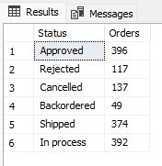

**2. Revenue (الأرباح للبضائع ):**

select Sum(LineTotal) AS Revenue

from SQLToturial.dbo.Sales$

Where Status in('Approved','In process','Shipped')

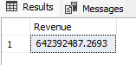

**3. Total Tax(القيمة الإجمالية للضريبة):**

select Sum(TaxAmt) AS TotalTax

from SQLToturial.dbo.Sales$

Where Status in('Approved','In process','Shipped')

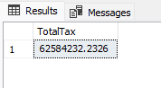

**4. Total Freight(القمية الإجمالية للشحن):**

select Sum(Freight) AS TotaFreight

from SQLToturial.dbo.Sales$

Where Status in('Approved','In process','Shipped')

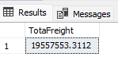

**5. TotalDue(القيمة الإجمالية):**

select Sum(TotalDue) AS TotalDue

from SQLToturial.dbo.Sales$

Where Status in('Approved','In process','Shipped')

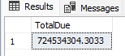

**B. Daily Trend for Total Orders (مجموع الطلبات بأيام الأسبوع)**

SELECT DATENAME(DW, DueDate) AS Daily_name, COUNT(Distinct OrderID) AS

Total_Orders

from SQLToturial.dbo.Sales$

GROUP BY DATENAME(DW, DueDate)

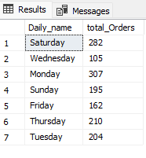

**C. Monthly Trend for Orders**

SELECT DATENAME(MONTH, DueDate) AS Month_name, COUNT(Distinct OrderID) AS

total_Orders

from SQLToturial.dbo.Sales$

Where Status in('Approved','In process','Shipped')

GROUP BY DATENAME(MONTH, DueDate)

**D. % of Sales by Product Sub Category**

SELECT ProductSubCategory, CAST(SUM(LineTotal) AS DECIMAL(13,2)) as Total_revenue,

CAST(SUM(LineTotal) * 100 / (SELECT SUM(LineTotal) from SQLToturial.dbo.Sales$) AS DECIMAL(13,2)) AS PCT

FROM SQLToturial.dbo.Sales$

Where Status in('Approved','In process','Shipped')

GROUP BY ProductSubCategory

Order By PCT Desc

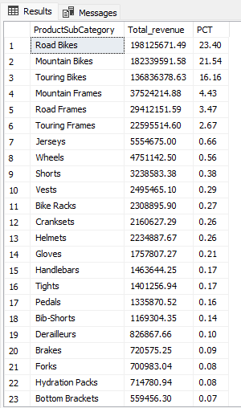

**E. % of Return by Product Sub Category**

SELECT ProductSubCategory, CAST(SUM(LineTotal) AS DECIMAL(13,2)) as Total_Return,

CAST(SUM(LineTotal) * 100 / (SELECT SUM(LineTotal) from SQLToturial.dbo.Sales$) AS DECIMAL(13,2)) AS PCT

FROM SQLToturial.dbo.Sales$

Where Status in('Cancelled','Backordered','Rijected')

GROUP BY ProductSubCategory

Order By PCT Desc

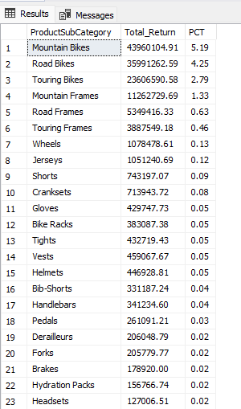

**F. % of Sales by Product Category**

SELECT ProductCategory, CAST(SUM(LineTotal) AS DECIMAL(13,2)) as Total_revenue,

CAST(SUM(LineTotal) * 100 / (SELECT SUM(LineTotal) from SQLToturial.dbo.Sales$

Where Status in('Approved','In process','Shipped')) AS DECIMAL(13,2)

) AS PCT

FROM SQLToturial.dbo.Sales$

Where Status in('Approved','In process','Shipped')

GROUP BY ProductCategory

ORDER BY PCT Desc

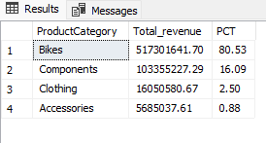

**J. % of Return by Product Category**

SELECT ProductCategory, CAST(SUM(LineTotal) AS DECIMAL(13,2)) as Total_Return,

CAST(SUM(LineTotal) * 100 / (SELECT SUM(LineTotal) from SQLToturial.dbo.Sales$

Where Status in('Cancelled','Backordered','Rijected')) AS DECIMAL(13,2)

) AS PCT

FROM SQLToturial.dbo.Sales$

Where Status in('Cancelled','Backordered','Rijected')

GROUP BY ProductCategory

ORDER BY PCT Desc

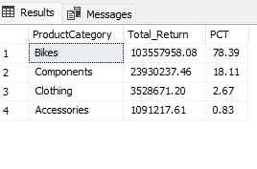

**H. Total Pizzas Sold by Pizza Category**

SELECT pizza_category, SUM(quantity) as Total_Quantity_Sold

FROM pizza_sales

WHERE MONTH(order_date) = 2

GROUP BY pizza_category

ORDER BY Total_Quantity_Sold DESC

***Output***

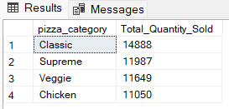

**G. Top 5 Pizzas by Revenue**

SELECT Top 5 pizza_name, SUM(total_price) AS Total_Revenue

FROM pizza_sales

GROUP BY pizza_name

ORDER BY Total_Revenue DESC

